**SELECTIVE REPEAT PROTOCOL**

**Bachelor of Technology**

**Computer Science and Engineering**

Submitted By

NAME – ABHIRUP BAG

ROLL NUMBER – 13000122082

DEPARTMENT – CSE(B)

SEMESTER – 6

PAPER – COMPUTER

NETWORKS (PCC-CS602)

MARCH 2025



**Techno Main**

**EM-4/1, Sector-V, Salt Lake**

**Kolkata- 700091**

**West Bengal**

**India**

**Table of Contents**

**1. Introduction 3**

**2. Backgrounds 4**

**3. Working Mechanism of Selective Repeat Protocol 4**

**A. Key Concepts 4**

**B. Steps in Operation 5**

**C. Example Scenario 5**

**4. Window Size Calculation 7**

**5. Advantages of Selective Repeat Protocol 8**

**6. Disadvantages of Selective Repeat Protocol 8**

**7. Applications 8**

**8. Comparison with Other Protocols 9**

**9. Conclusion 9**

**10. References 9**

# Introduction

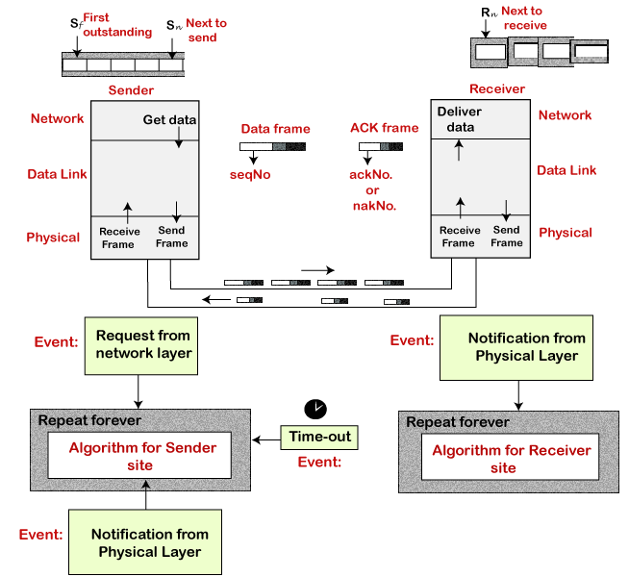In computer networks, reliable data transmission is a crucial aspect of communication. Various Automatic Repeat request (ARQ) protocols are used to ensure error-free delivery of packets. The Selective Repeat (SR) Protocol is an advanced ARQ protocol that enhances efficiency by retransmitting only the erroneous or lost packets instead of retransmitting entire sequences, as done in Go-Back-N ARQ.

This report provides a detailed overview of the Selective Repeat Protocol, covering its working principles, advantages, disadvantages, comparison with other ARQ protocols, and real-world applications.

The design of the Selective Repeat ARQ protocol

**Why Selective Repeat Protocol?**

The go-back-n protocol works well if errors are less, but if the line is poor, it wastes a lot of bandwidth on retransmitted frames. An alternative strategy, the selective repeat protocol, is to allow the receiver to accept and buffer the frames following a damaged or lost one. Selective Repeat attempts to retransmit only those packets that are actually lost (due to errors):

* Receiver must be able to accept packets out of order.
* Since receiver must release packets to higher layer in order, the receiver must be able to buffer some packets.

# Backgrounds

* 1. **Reliable Data Transmission**

In computer networks, reliable data transmission ensures that data sent from a sender is received correctly by the receiver, despite potential issues like packet loss, corruption, or reordering. Protocols like Stop-and-Wait, Go-Back-N, and Selective Repeat are designed to achieve this reliability.

* 1. **Limitations of Stop-and-Wait and Go-Back-N**
     1. **Stop-and-Wait Protocol:** This protocol sends one frame at a time and waits for an acknowledgment (ACK) before sending the next frame. While simple, it is highly inefficient for high-latency or high-bandwidth networks.
     2. **Go-Back-N Protocol:** This protocol allows multiple frames to be sent without waiting for individual ACKs. However, if a frame is lost or corrupted, all subsequent frames must be retransmitted, leading to inefficiency.

# Working Mechanism of Selective Repeat Protocol

## Key Concepts

* + 1. **Sender and Receiver Windows:**
       1. Both sender and receiver maintain a window of acceptable sequence numbers.
       2. The sender transmits up to ‘N’ frames without waiting for an acknowledgment.
       3. The receiver accepts frames out of order and stores them in a buffer until all previous frames are received.
    2. **Sequence Numbers:** Each frame is assigned a unique sequence number to identify it. The sequence numbers are finite and wrap around after reaching a maximum value.
    3. **Acknowledgments (ACKs):**
       1. The receiver sends an ACK (acknowledgment) for each correctly received frame.
       2. If a frame is lost or corrupted, the sender retransmits only that specific frame, reducing unnecessary retransmissions.
    4. **Retransmission:** The sender retransmits only the frames that are not acknowledged within a timeout period.
    5. **Buffering:**
       1. Since SR allows out-of-order reception, the receiver must buffer received frames until the missing frames arrive.

## Steps in Operation

* + 1. **Sender Side:**
       1. The sender sends frames within its window size.
       2. It starts a timer for each frame sent.
       3. If an ACK is received for a frame, the sender slides its window forward and stops the timer for that frame.
       4. If a timeout occurs for a frame, the sender retransmits that specific frame.
    2. **Receiver Side:**
       1. The receiver accepts frames within its window and sends ACKs for correctly received frames.
       2. If a frame is received out of order, it is buffered until all preceding frames are received.
       3. If a frame is lost or corrupted, the receiver does not send an ACK, prompting the sender to retransmit.
    3. **Handling Duplicates:**
       1. Both sender and receiver use sequence numbers to detect and discard duplicate frames.
    4. **Retransmission**
       1. If the sender does not receive an ACK within a predefined timeout period, it retransmits only the missing frame.
       2. The process continues until all frames are successfully received.

## Example Scenario

* + 1. Suppose the sender's window size is 4, and frames 0, 1, 2, and 3 are sent.
    2. The receiver successfully receives frames 0, 1, and 3 but loses frame 2.
    3. The receiver sends ACKs for frames 0 and 1 but does not send an ACK for frame 2.
    4. The sender retransmits frame 2 after a timeout.
    5. Once frame 2 is received, the receiver sends an ACK for frames 2 and 3, and the sender slides its window forward.

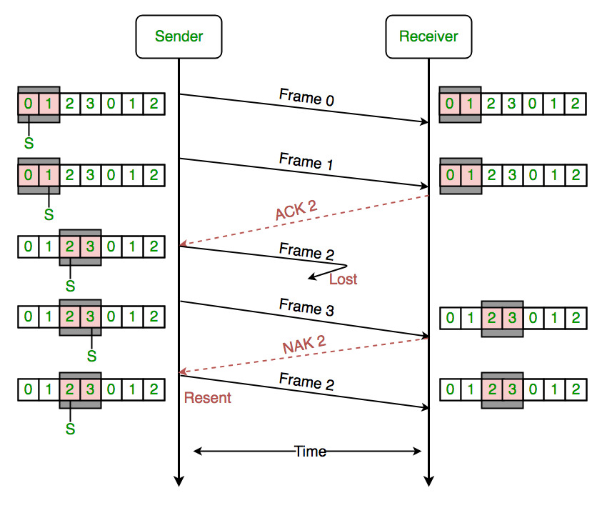

Example of the Selective Repeat ARQ protocol

**Figure –** the sender only retransmits frames, for which a NAK is received efficiency of Selective Repeat Protocol (SRP) is same as GO-Back-N’s efficiency:

Efficiency = N/(1+2a)  
Where a = Propagation delay / Transmission delay   
Buffers = N + N  
Sequence number = N (sender side) + N (Receiver Side)

If,

**Tt(ack):** Transmission delay for acknowledgment,

**Tq:** Queuing delay

**Tpro:** Processing delay is mention

We know that the Efficiency = Useful time / Total cycle time

=Tt(data) /Tt(data)+2*Tp+Tq+Tpro+Tt(ack)

Tt(data) : Transmission delay for Data packet  
Tp : propagation delay for Data packet  
Tq: Queuing delay  
Tpro: Processing delay  
Tt(ack): Transmission delay for acknowledgment

Above formula is applicable for any condition, if any of the things are not given, we assume it to be 0.

# Window Size Calculation

The window size for Selective Repeat must be carefully chosen to avoid confusion between new and old frames.

**Maximum Window Size:**

$$W≤\frac{2^{n}}{2}$$

Where:

* W is the window size,
* n is the number of bits used for the sequence number.

For example, if 𝑛 = 3 (i.e., sequence numbers range from 0 to 7), the window size should be:

$$W≤\frac{2^{3}}{2}=4$$

This prevents ambiguity when retransmitting frames.

# Advantages of Selective Repeat Protocol

* 1. **Efficient Bandwidth Utilization:** Unlike Go-Back-N, which retransmits entire sequences, SR retransmits only lost frames, reducing bandwidth wastage.
  2. **Improved Throughput:** Since it allows out-of-order reception, the network remains active without unnecessary retransmissions.
  3. **Reduced Delay:** It ensures that correctly received frames do not need to be resent, making it suitable for high-latency networks.
  4. **Better Performance in Error-Prone Networks:** Useful in wireless and satellite communications, where errors are frequent.

# Disadvantages of Selective Repeat Protocol

* 1. **Higher Complexity:** Requires buffering at the receiver and additional logic to reorder frames.
  2. **Increased Memory Requirement:** Since the receiver must store out-of-order frames, it requires additional buffer space.
  3. **Processing Overhead:** Maintaining sequence numbers, handling out-of-order packets, and sending individual ACKs increase processing time.

# Applications

* 1. **Wireless Communication (Wi-Fi, LTE, 5G):** Selective Repeat is used to minimize retransmissions and optimize bandwidth.
  2. **Satellite Communication:** Due to long delays and high error rates, Selective Repeat ensures only necessary retransmissions.
  3. **Transmission Control Protocol (TCP):** Some implementations of TCP use Selective Repeat to improve performance over long-distance networks.
  4. **Video Streaming & VoIP:** Selective Repeat helps reduce packet loss and improve quality of service in real-time applications.

# Comparison with Other Protocols

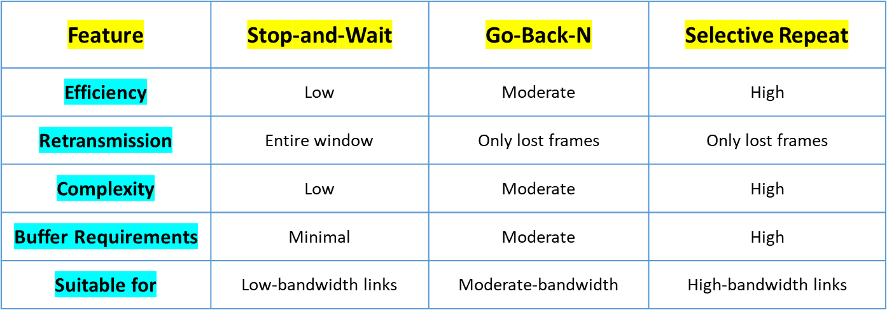

# Conclusion

The Selective Repeat Protocol is a powerful ARQ mechanism that improves reliability, efficiency, and throughput by selectively retransmitting lost or corrupted frames. While it offers significant advantages over Go-Back-N, its implementation requires higher complexity and memory management.

Selective Repeat is widely used in modern networks, including wireless, satellite, and high-speed communication systems, where minimizing retransmissions is critical for performance.

# References

* **"Computer Networks" –** Andrew S. Tanenbaum & David J. Wetherall, Pearson, 5th Edition (2010).
* **"Computer Networking: A Top-Down Approach" –** James F. Kurose & Keith W. Ross, Pearson, 8th Edition (2021).
* **"Data and Computer Communications" –** William Stallings, Pearson, 10th Edition (2017).
* **"Data Communications and Networking"** – Behrouz A. Forouzan